Mean, Median, Mode and Range-Answers
Key Stage 3: 2003 Paper 1 Level 3-5
1.
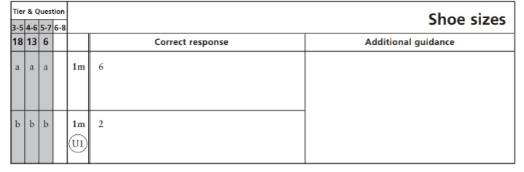
Key Stage 3: 2003 Paper 1 Level 4-6
2.
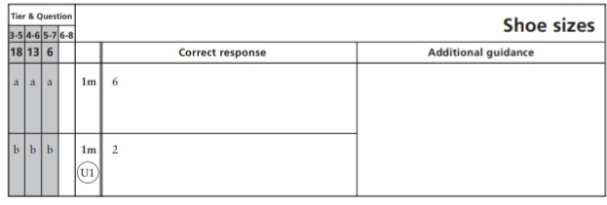
Key Stage 3: 2005 Paper 1 Level 3-5
3.
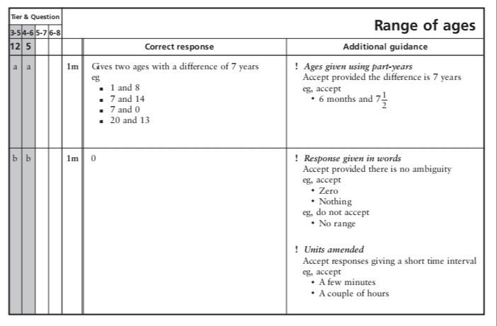
4.
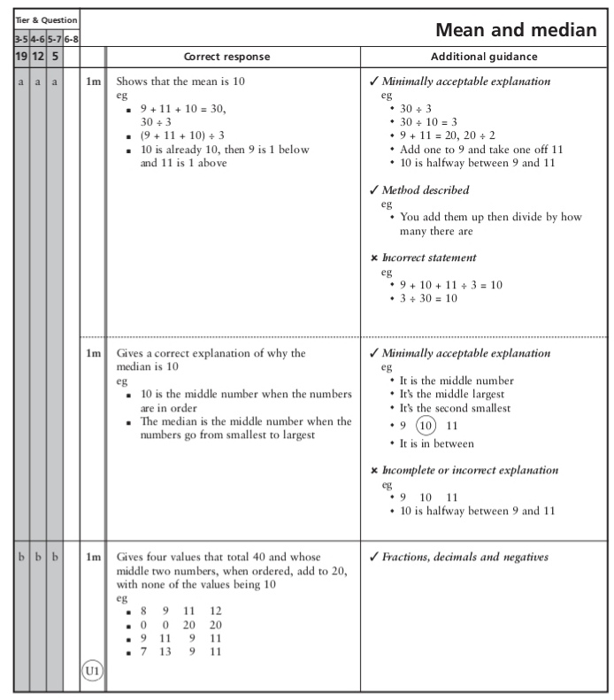
Key Stage 3: 2005 Paper 1 Level 4-6
5.
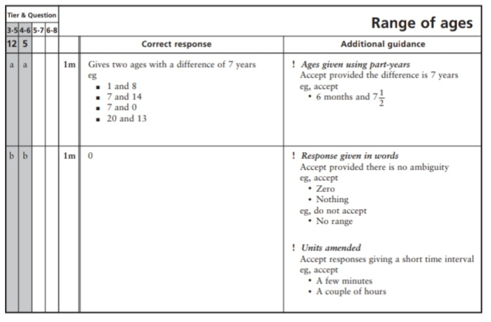
6.
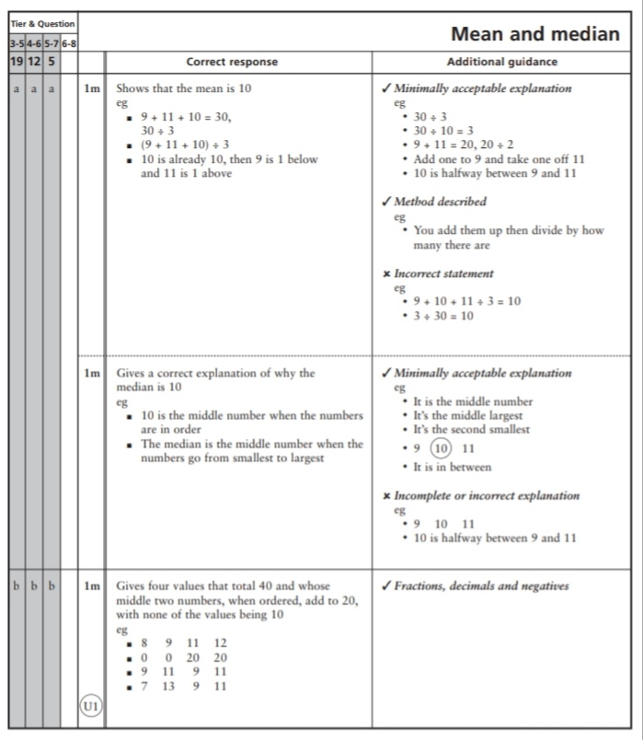
Key Stage 3: 2006 Paper 1 Level 4-6
7.
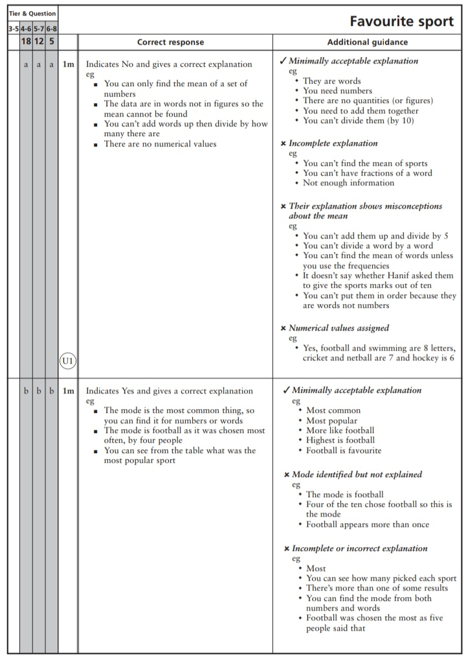
Key Stage 3: 2007 Paper 2 Level 3-5
8.
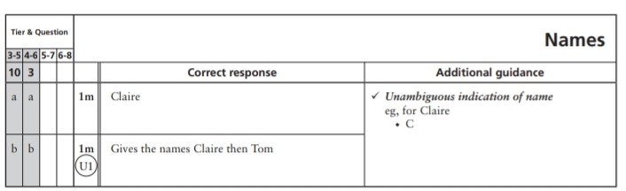
Key Stage 3: 2007 Paper 2 Level 4-6
9.
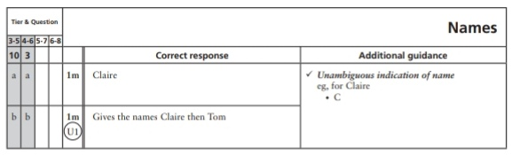
Key Stage 3: 2008 Paper 1 Level 3-5
10.
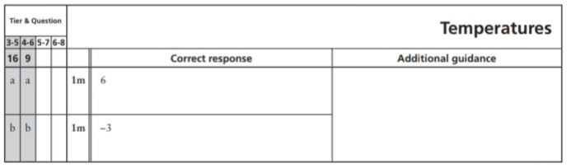
Key Stage 3: 2008 Paper 1 Level 4-6
11.
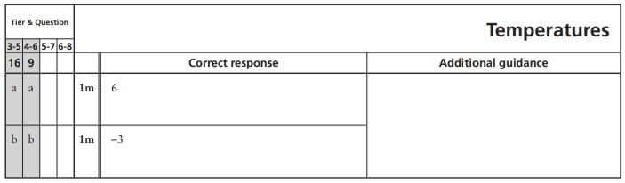
12.
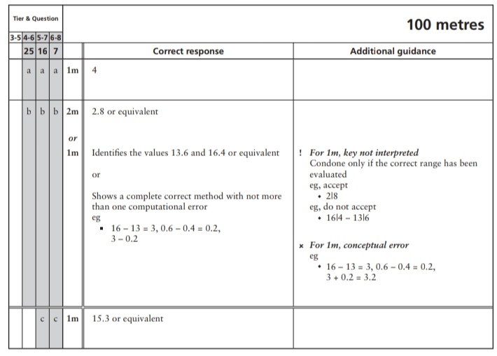
Key Stage 3: 2008 Paper 2 Level 4-6
13.
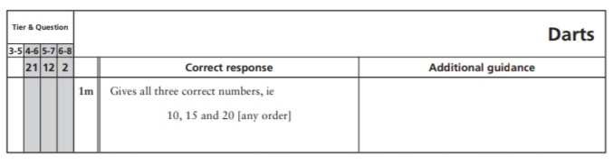
Key Stage 3: 2009 Paper 2 Level 3-5
14.
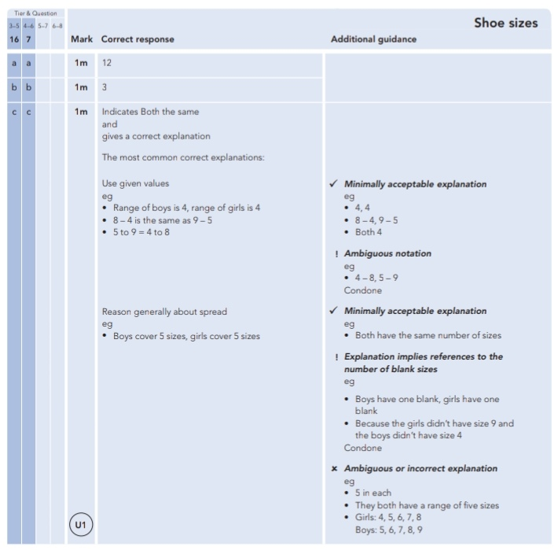
Key Stage 3: 2009 Paper 2 Level 4-6
15.

